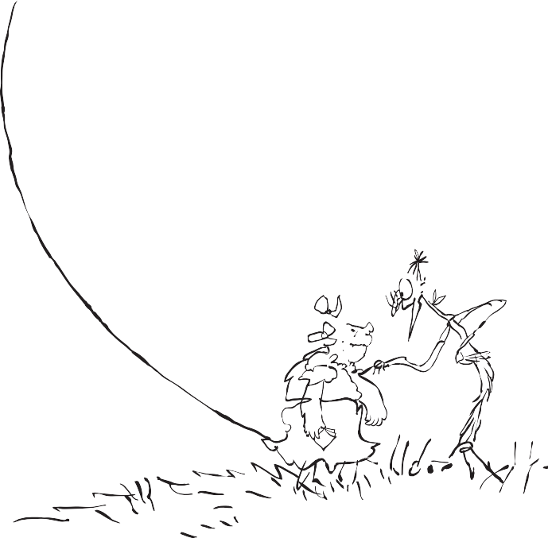
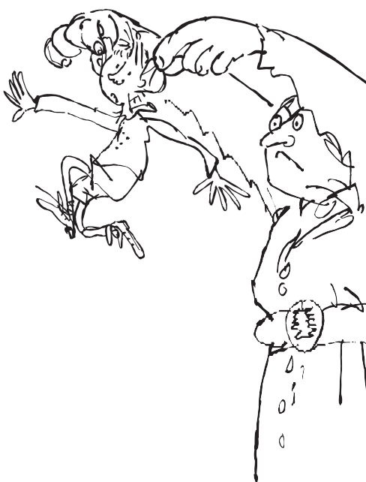
Roald Dahl
Creating Characters
Create a character: a villain. Remember to use positive and/or negative language when describing them, to help explain their character.
©The Roald Dahl Story Company Limited/ Quentin Blake 2019

How do they speak?

Villain’s Name

What do they look like?

How do they move?
What do they smell like?

Why is there conflict between the two characters?

