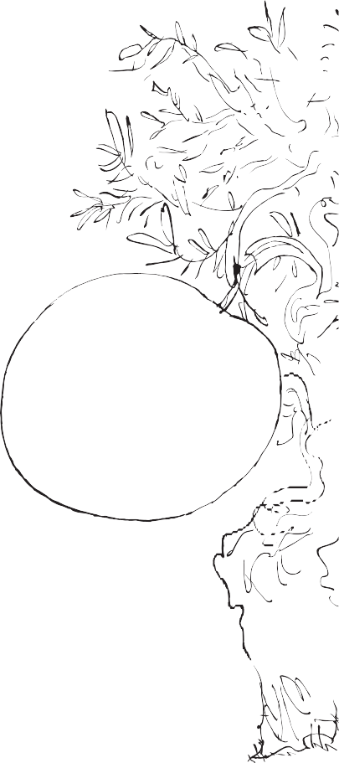
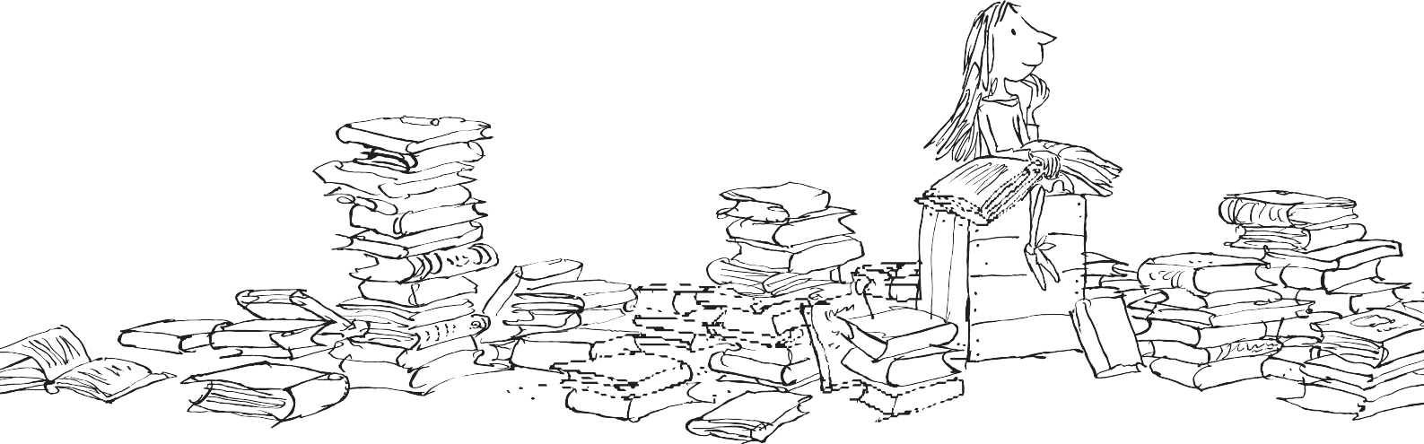
Roald Dahl
Creating Characters
Create a character: a hero. Remember to use positive and/or negative language when describing them, to help explain their character.
©The Roald Dahl Story Company Limited/ Quentin Blake 2019

How do they speak?

Hero’s Name

What do they look like?

How do they move?

What do they smell like

